**Problem Statement**

I attempted all three problems as well as the extra credit cube. The flower image is distorted using an algorithm which divides the image into quadrants of proportionally-distorted quadrants. The teacup is read into the program and then displayed, and can be seen from different angles using the mouse. The cube has the flower mapped onto each side, and can be rotated using the mouse.

**Algorithm Design**

The image distortion involves breaking up the image into four separate quadrants. The dimensions of these quadrants are determined by the mouse. Every pixel from the old image is mapped to its corresponding new image, with the pixels being inserted at the position of (x*xratio, y*yratio) relative to the original image. xratio and yratio are the corresponding ratios of the new proportional quadrant vs the original quadrant, which was merely height/2 and width/2. If the quadrant is stretched, there are missing pixels, so we have to interpolate. Interpolation is done by iterating through the image and finding pixels that are not initialized. Originally, pixels are initialized when the binary data is converted to a series of structs, which contain RGB values and a boolean that tells if the pixel has been addressed. I iterate through all of the pixels where the boolean is false, and assign them the pixel value of the average of all the 8 neighbors, excluding those which have not been initialized themselves. For the teacup, the data is simply read in and displayed, and the cube is drawn the normal way with the image texture mapped to each face.

**How to Run the Code**

Double click on the exe to run. Left click and drag to distort the flower image. Press ‘R’ to rotate the flower image. Right click to bring up options. “Teacup” will display the teacup. Left click and drag to show the teacup from different angles. “Cube” will show the cube. Left click and drag to show the cube from different angles.

**Screenshots**

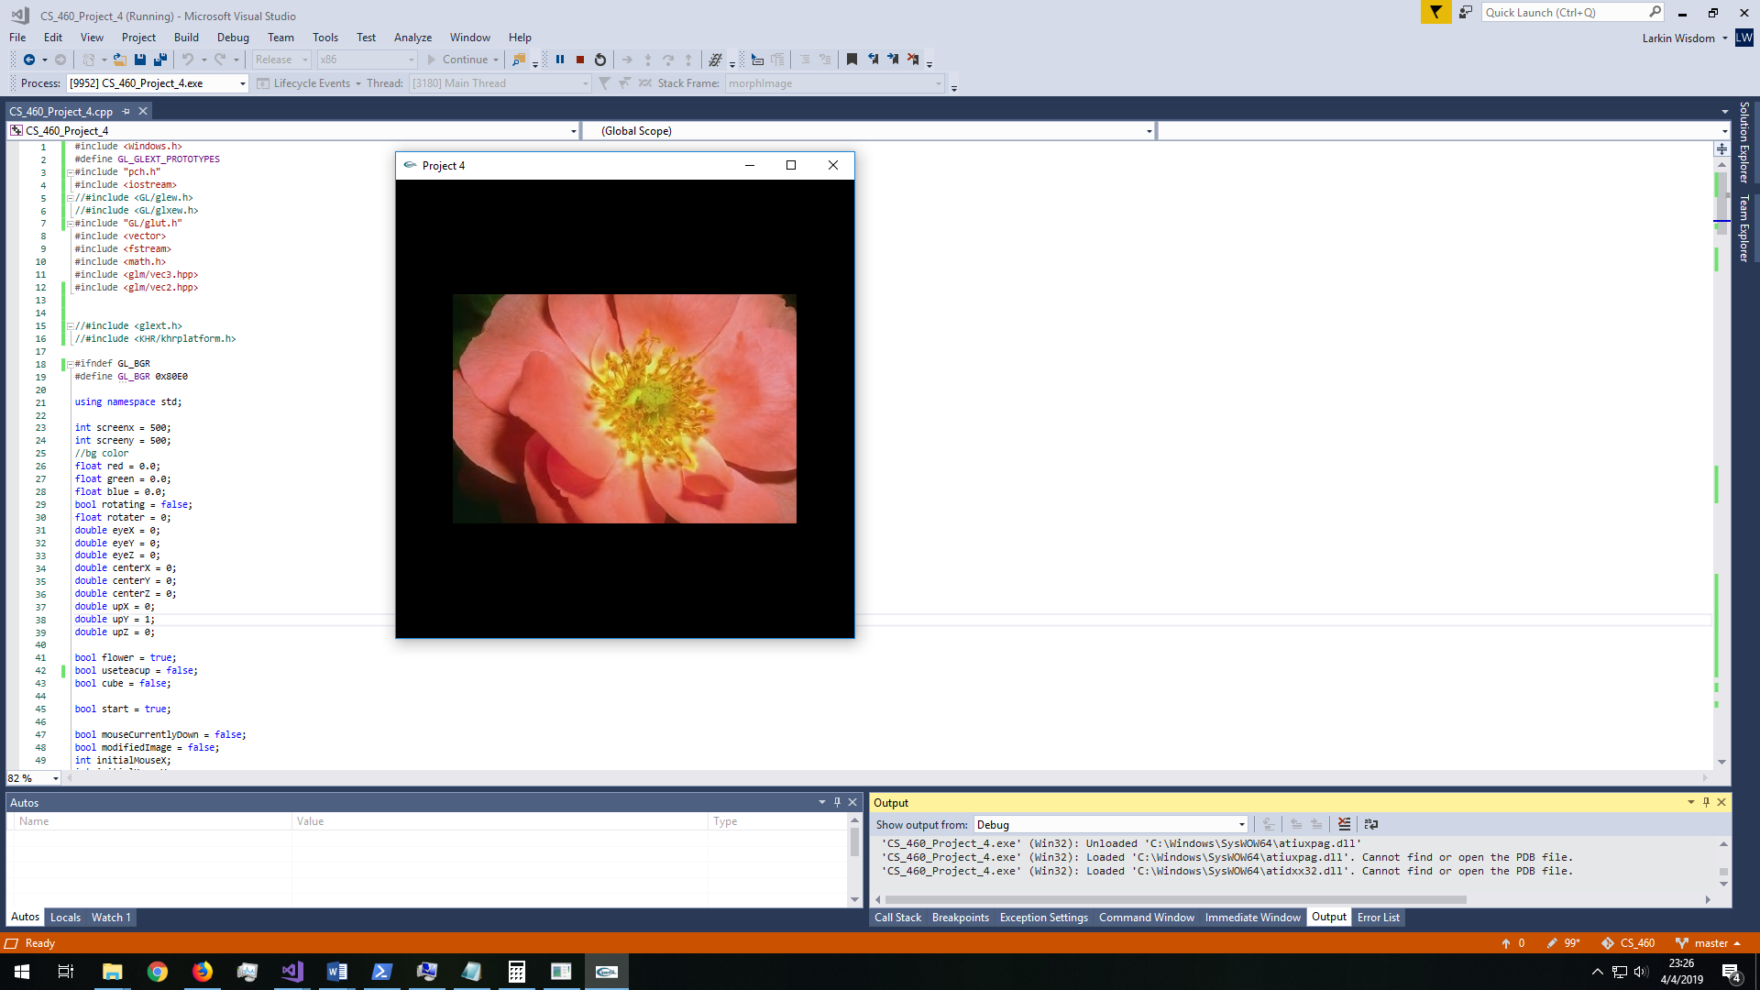

Default display of the flower

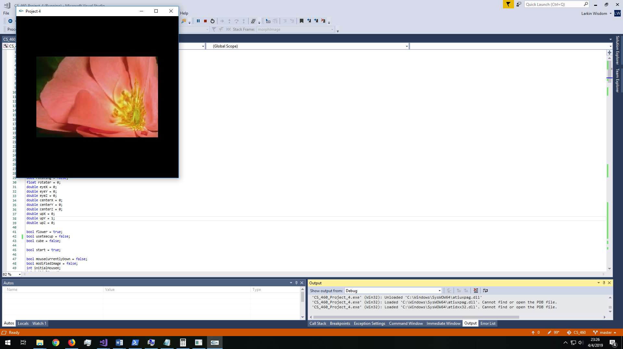

Flower after it has been distorted

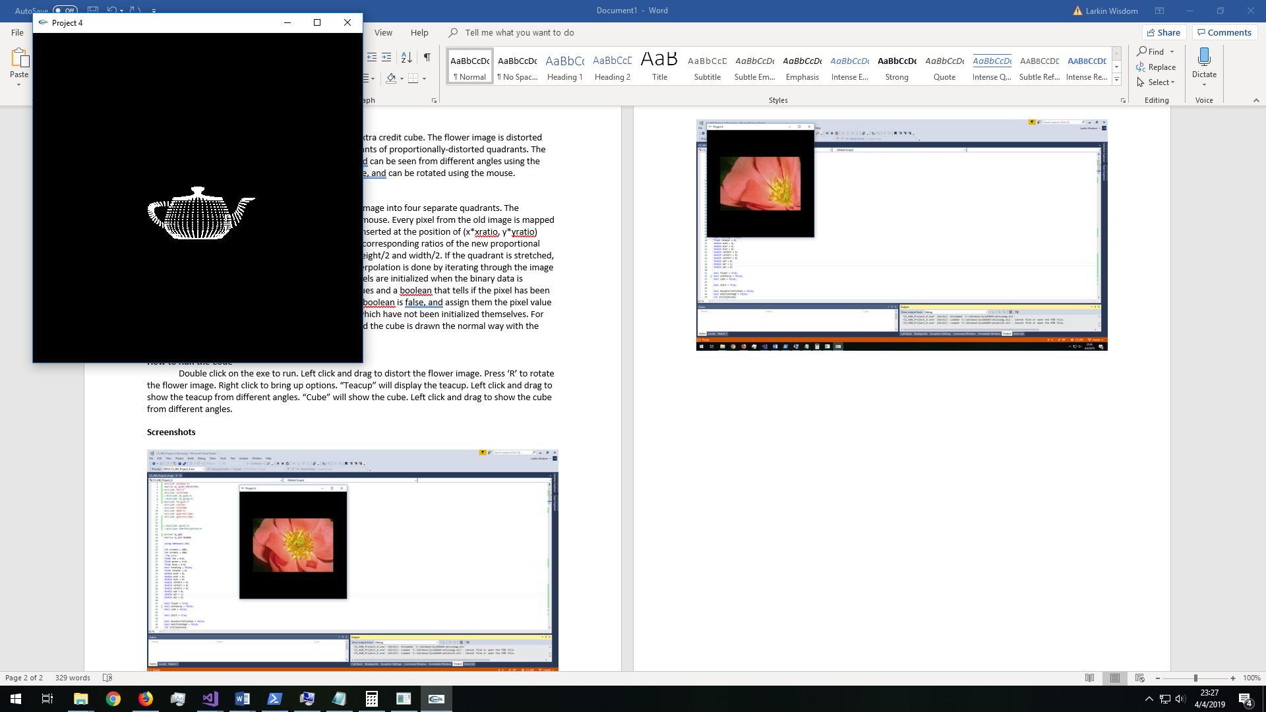

Default display of the teacup

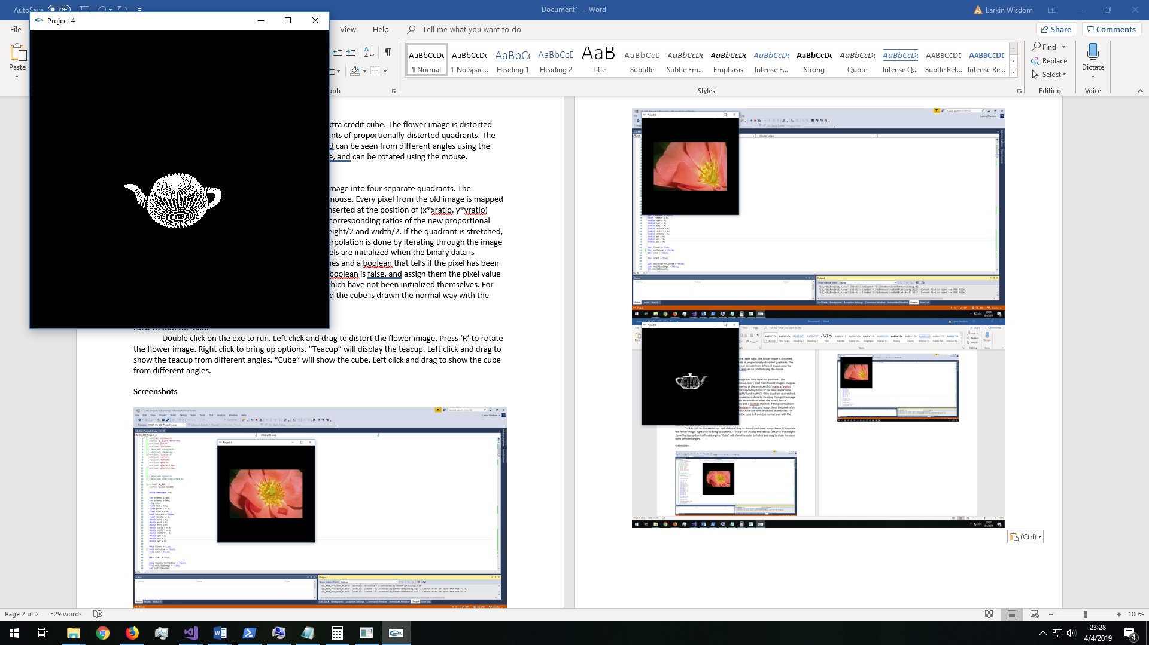

Teacup after it has been rotated

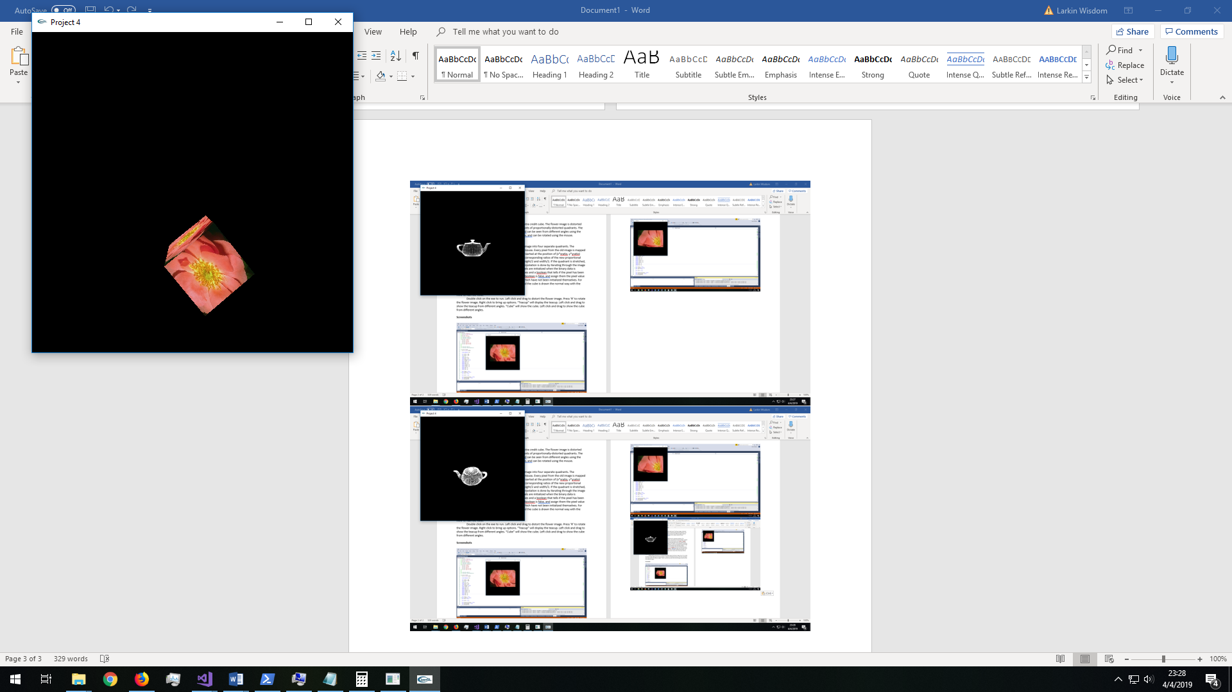

Cube in one angle

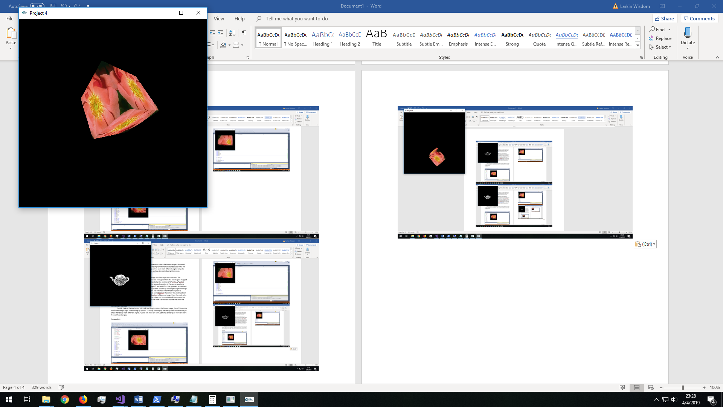

Cube at a different angle